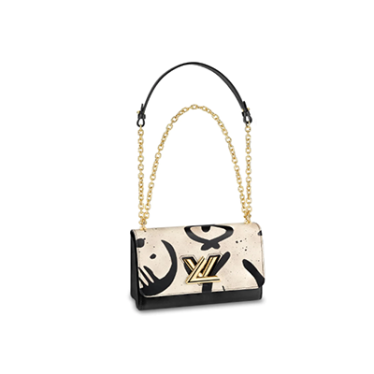

Twist MM Other leathers

PRODUCT DETAILS

**- L 9 x H 6.7 x W 3.7 inches**

**- Black and White Tribal Print**

**- Calf leather body and trim**

**- Microfiber lining**

**- Gold-color hardware**

**- Sliding chain shoulder strap with leather pad**